**ASSIGNMENT 1**

**Design of Home Automation with Tinker CAD :**

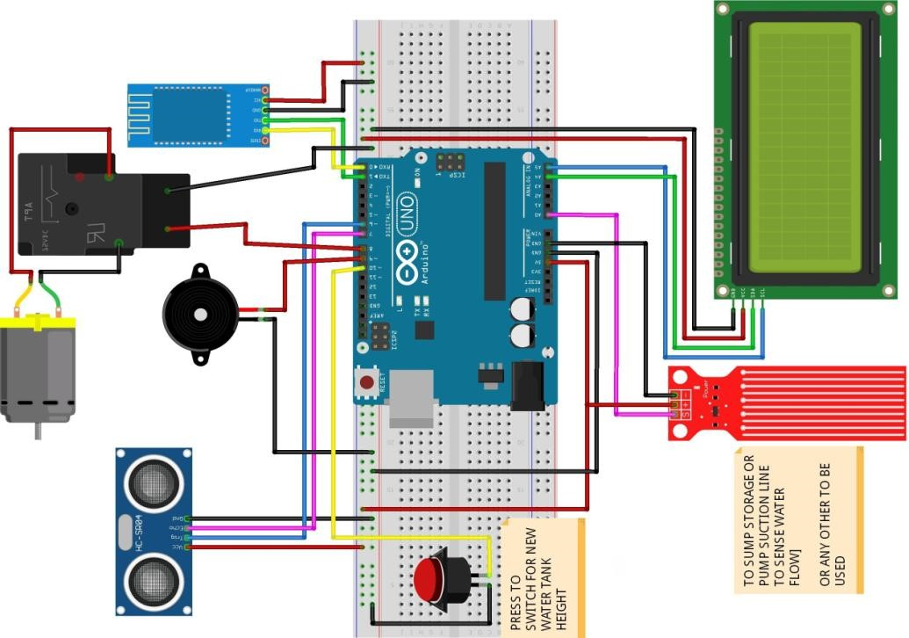

#include<SoftwareSerial.h>

int bulb1 = 8;

int bulb2 = 9;

int bulb3 = 10; int bulb4 = 11;

SoftwareSerialbt (0,1); /* (Rx,Tx) */

String str;

void setup()

{

bt.begin(9600); Serial.begin(9600);

pinMode(bulb1,OUTPUT); pinMode(bulb2,OUTPUT); pinMode(bulb3,OUTPUT); pinMode(bulb4,OUTPUT);

}

void loop()

{

if (bt.available())

{

str = bt.read(); Serial.println(str); //bulb1 if(str==”bulb1on”)

{

digitalWrite(bulb1,HIGH); Serial.println(“BUlB 1 is ON”);

}

else if(str==”bulb1 off”)

{

digitalWrite(bulb1,LOW); Serial.println(“BUlB 1 is OFF”);

}

else

{

digitalWrite(bulb1,LOW);

}

//bulb2 if(str==”bulb2on”)

{

digitalWrite(bulb2,HIGH); Serial.println(“BUlB 2 is ON”);

}

else if(str==”bulb2 off”)

{

digitalWrite(bulb2,LOW); Serial.println(“BUlB 2 is OFF”);

}

else

{

digitalWrite(bulb2,LOW);

}

////bulb3 if(str==”bulb3on”)

{

digitalWrite(bulb3,HIGH); Serial.println(“BUlB 3 is ON”);

}

else if(str==”bulb3 off”)

{

digitalWrite(bulb3,LOW);

Serial.println(“BUlB 3 is OFF”);

}

else

{

digitalWrite(bulb3,LOW);

}

//bulb4 if(str==”bulb4on”)

{

digitalWrite(bulb4,HIGH); Serial.println(“BUlB 4 is ON”);

}

else if(str==”bulb4 off”)

{

digitalWrite(bulb4,LOW);

Serial.println(“BUlB 4 is OFF”);

}

else

{

digitalWrite(bulb4,LOW);

}

}

}